**Experiment 1 Results:**

Filename: amazon_cells_labelled.txt  
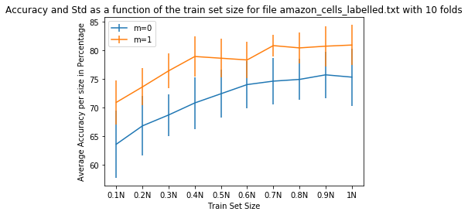

Filename: imdb_labelled.txt

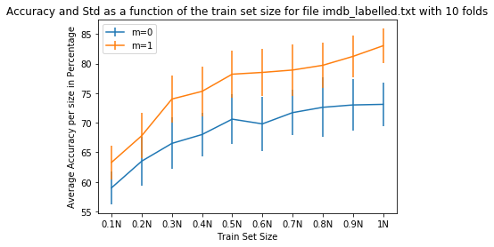

Filename: yelp_labelled.txt

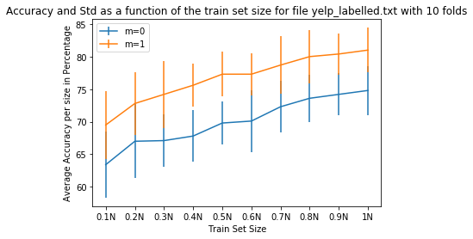

Observations made:

As the size of train set size increases, the accuracy also increases, which holds true for most of the models. F**or m=0, as train size increases, accuracies increase as it will have less and less words whose occurrences are zero.** Accuracies for m=1 are better than that of m=0. Also, standard deviation is little less in case of m=1 as compared to m=0.

**Experiment 2 Results:**

Filename: amazon_cells_labelled.txt

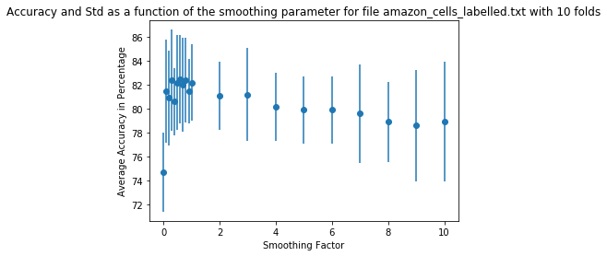

Filename: imdb_labelled.txt

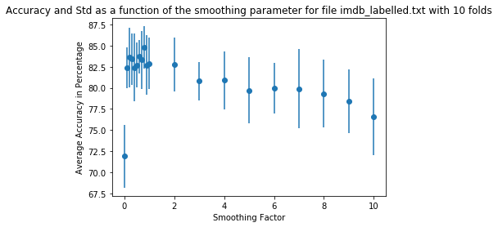

Filename: yelp_labelled.txt

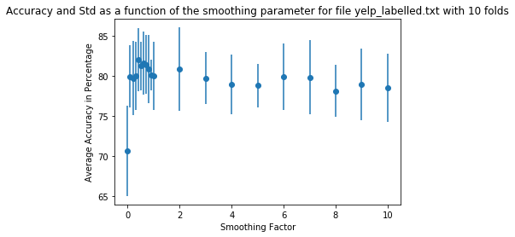

**Conclusion on the graph result:**

When m=0, average accuracy is very less as compared to other observations because, some words might have zero occurrences, resulting in zero probability, which in turn results in incorrect predictions.